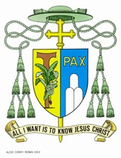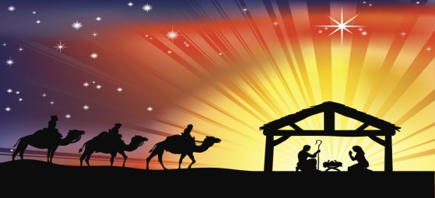
Bishop Arnold Boghaert Catholic Centre
Turkey Lane, P.O. Box 790
Roseau, Commonwealth of Dominica
Tel. (767) 448-2837 – (767) 448-8717
Fax (767) 448-3404
e.mail: bishop@cwdom.dm

24th December, 2017.

Dear Brothers in the Episcopate, Clergy & Religious
and faithful in the AEC Region & beyond

The last three months have been quite daunting for the Church, the Government and the entire people of the Commonwealth of Dominica after the passing of Hurricane Maria in September 2017. Depicted by the obvious disturbance to individual lives and the setbacks to national development, it has been a learning experience for us. The outpouring of generosity from our brothers and sisters in the Region and beyond has been unprecedented. The flow of volunteers who came to our assistance is a model for true Caribbean and international solidarity.

Therefore, in this season of good cheer, I take this opportunity to express heartfelt thanks to all the individuals, groups and organizations that assisted and are still assisting us through these difficult times.

We are keenly aware of the challenges still ahead. However, with the continued support of all of you coupled with the resilience of our people, we will succeed in building a stronger and better Dominica.

May the peace that emanates from the Christ-Child find a ready abode in each of our hearts and may the New Year bring success, health and prosperity to all.

Sincerely yours in Christ,

Most Rev. Gabriel Malzaire
Bishop of Roseau

